EL TORO
THE BEST TRUCK STOP IN TOWN
A film by Danielle Sturk

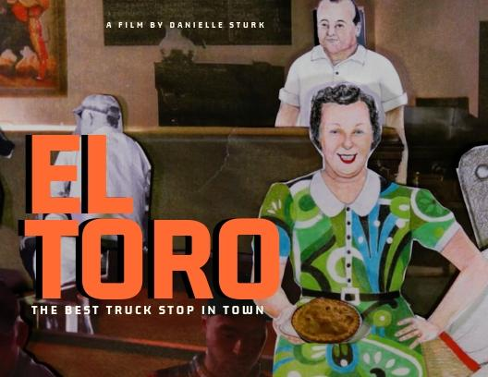

Press Kit - El Toro
Written, Directed and Produced by Danielle Sturk
Canada | 2018 | 44 minutes | Documentary

“whimsically weird and seriously avant-garde”
Alison Gillmor, Winnipeg Free Press, February 9th, 2019

The Story
Romance and tragedy bind eight siblings who work with their parents at their family-run truck stop diner deep in the entrails of 1960’s industrial Saint-Boniface. El Toro no longer exists between the old Canada Packers and the Union Stock Yards but does very much so in the minds of the surviving DeGagné brood.

The film El Toro rebuilds the walls, stools, and atmosphere of the restaurant, recreating a surreal, rich, and imaginative world, evoking a lost time and place through the lens of memory, nostalgia and love. And yes, animals were consumed, filmed, drawn, and animated in this hybrid documentary.

Filmmaker Statement
This funky film began in 2011 at a family reunion around a pool party with an audio recorder in one hand and a hamburger in the other. It ended years later with my fingers placing frozen corn kernels around an illustration of my Mémère, drawn by Diana Thorneycroft, ready for Rhayne Vermette to photograph with the Oxberry camera.

With the absolute and continued support of the Manitoba Arts Council since 2011, I was afforded the immense privilege to explore and develop new (to me) forms of visual storytelling, and the pleasure to do so with outstanding Manitoban artists: Freya Olafson, Brian Rougeau, Diana Thorneycroft, Peter Graham, Rhayne Vermette, Gabriel Levesque, Stephanein Boulet, Dany Joyal and many others.

The support of the Canada Council for The Arts as well as the Winnipeg Arts Council is keenly appreciated, and was essential in the making of this film. This film employed 30 Manitobans and enticed 28 volunteers to assist us.

To my family of aunts and uncles, cousins, cousins’ kids, my own kids and their friends, who all pitched in to tell their story, or help to tell it by taking on the role of trucker or waitress, or props assistant – merci! Finally, a very warm thank you to my mom, Rachel DeGagné, whose non-fiction short story “Epitaph For El Toro”, inspired the making of this smorgasbord. Enjoy!

The Music
THE FRENCH SONG
“The French Song” or “Quand le soleil dit bonjour aux étoiles” sold over a million copies in 1964, at a time when the Beatles dominated the music charts. Lucille Marie Raymonde Savoie (later taking the stage name “Lucille Starr”) was born in 1938 and raised in Saint-Boniface, mere streets away from the El Toro diner, moving to the West coast with her family and later to LA for her music career. The song has both French and English in it, a nod to the francophone DeGagné family and to the era, when assimilation to the majority English speaking Winnipeg, was a question of survival.

HISTOIRE D’ANTAN
“Histoire d’antan”, commonly referred to as the Franco-Manitoban anthem, was written and composed by local Franco-Manitoban musical artist Gérard “Ziz” Jean in 1970. It has been performed and recorded by various artists, choirs, and even by the carillon of the Canadian Parliament Peace Tower in Ottawa (organized by Josée Roy). Here it is sweetly interpreted by Andrina Turenne in an album produced in 2012 by Le 100 Nons, Manitoba’s francophone music organization that has fostered French language music industry for over 50 years, and Le Conseil jeunesse provincial.

Media Coverage

Hot Docs 2019 Women Directors: Meet Danielle Sturk – “El Toro”
Women and Hollywood, April 27 2019
Interview with Writer/Director/Producer/Animator Danielle Sturk
We Are Moving Stories, April 2019
Winnipeg director Danielle Sturk's doc is a charming and meticulously constructed little film
Now Toronto, April 19 2019
A trailer that will melt your third eye
Slashtrailer review, March 23 2019
Le documentaire El Toro de la Manitobaine Danielle Sturk sera présenté à Toronto
ICI-Manitoba, 19 mars 2019

Media Coverage cont’

Memory, family myth and Winnipeg History
Winnipeg Free Press, February 9 2019

L’envie de mettre St. Boniface sur la map
La Liberté, 19 février 2019

Bygone St. Boniface restaurant remembered at Winnipeg documentary festival
CBC News - November 3 2018

Sturk's new film has a family focus
The Lance - October 29 2018

L'art de ranimer des bouts de mémoires
La Liberté - 28 février 2018

The Director
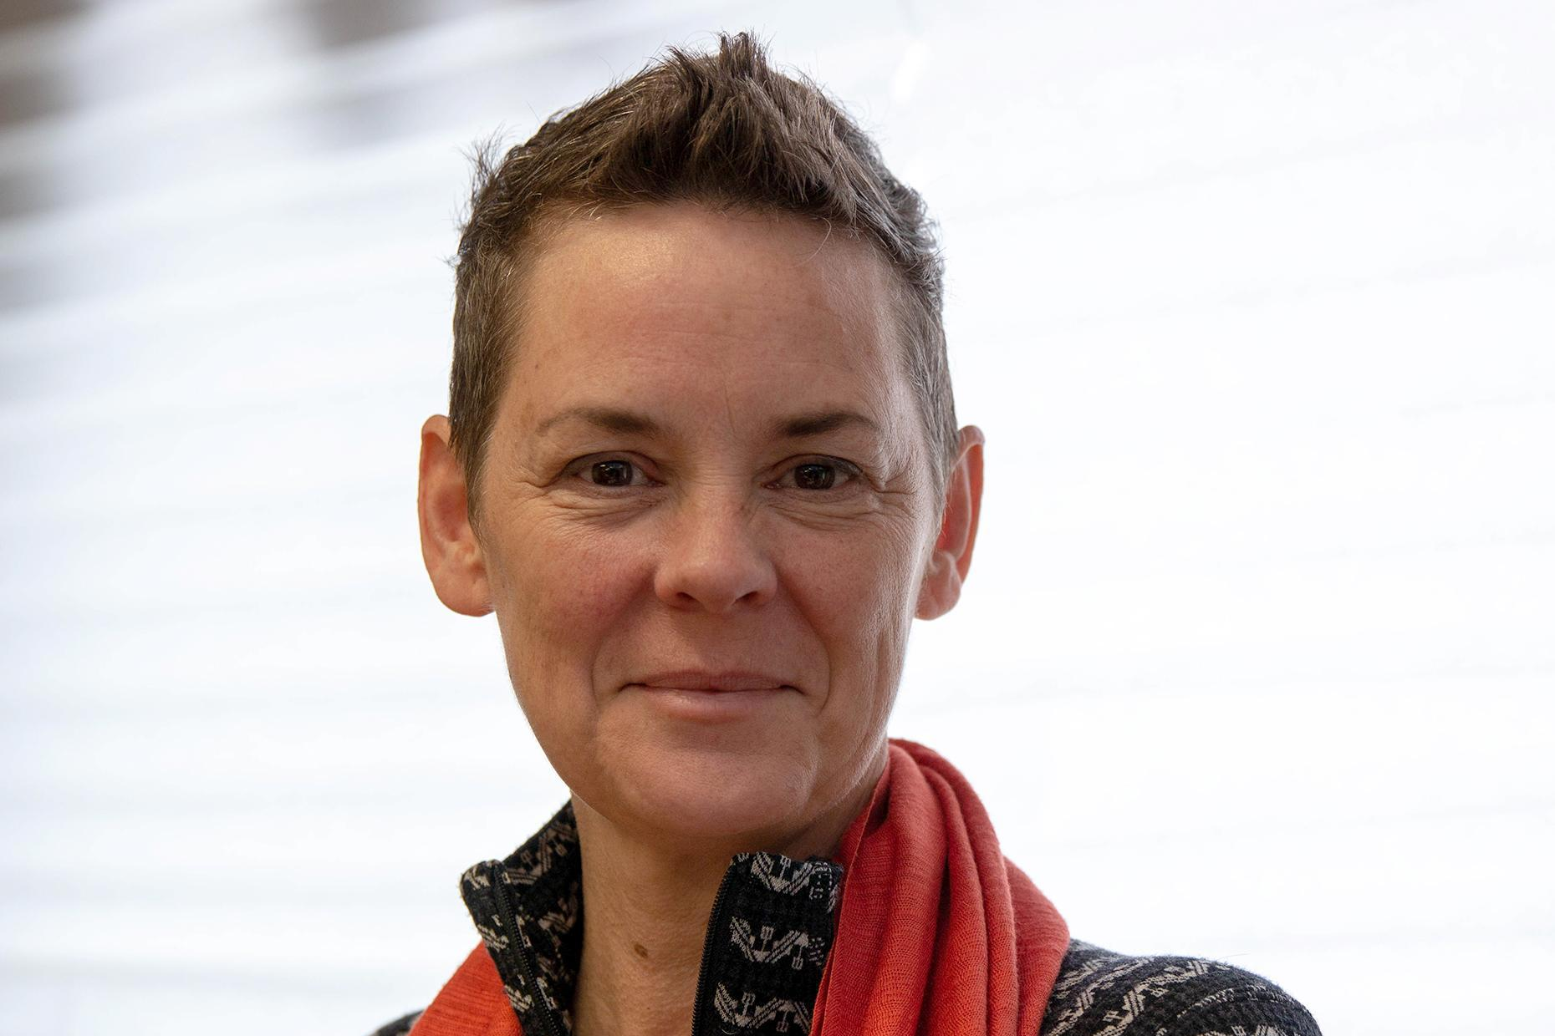
Danielle Sturk - Writer, Director, Producer
Credit: Journal La Liberté

A recipient of multiple arts awards from national, provincial and municipal arts councils, Danielle Sturk is a bilingual multi-disciplinary artist with a BA in Film/Theatre from the University of Winnipeg. Sturk began her career as a dance artist and choreographer, performing nationally and internationally from 1986-1997.

As filmmaker, her combined films d’auteur have been screened at over thirty film festivals and broadcast on most major Canadian English and French networks, such as CBC, Radio Canada, APTN, UNIS, TV5, MTS TV, Vision TV and for the National Film Board of Canada. She has been commissioned by the Canada Council for several web-based video projects, including artist portraits of Governor General Award recipients in Visual and Media Arts. Alongside her screen-based projects, she continues to produce live multidisciplinary stage events, and acts as National Artistic Director for the national broadcast concert “Indigenous Day Live” (formerly Aboriginal Day Live) on APTN live from multiple cities and stages across Canada, programming Indigenous musical and dance performances, and overseeing curated media art on LED screen on stages. Read more at daniellesturk.ca.

Creatives and Crew
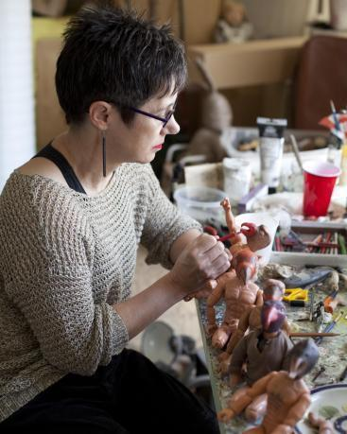
Diana Thorneycroft - Illustrations & Figurines
Diana Thorneycroft is a Winnipeg artist who has exhibited various bodies of work across Canada, the United States and Europe, as well as in Moscow, Tokyo and Sydney. She is the recipient of numerous awards including the 2016 Manitoba Arts Award of Distinction, an Assistance to Visual Arts Long-term Grant from the Canada Council, several Senior Arts Grants from the Manitoba Arts Council and a Fleck Fellowship from the Banff Centre for the Arts.
Thorneycroft taught as a sessional instructor at the University of Manitoba's School of Art for 25 years. Since 2010 she has been focusing on her studio practice full time, and has gallery representation in Canada, the US and Europe.
Read more on Diana Thorneycroft’s website http://www.dianathorneycroft.com/.

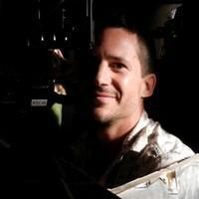
Gabriel Levesque - Director of Photography
Gabriel Levesque is a Winnipeg-based director of photography working locally and nationally. Gabriel attended the National Theater School Of Canada for a three year production program. He began his career in Winnipeg with Les Productions Rivard, a local french independent production company. He started as the in house camera assistant under the tutelage of longtime Director of Photography, Charles Lavack.

Gabriel became a Director of Photography for the company's bigger projects and over six years, contributed to over 100 hours of aired television programming. Gabriel has worked nationally on various projects. This includes filming the Gémeaux Award winning series “Destination Nor'Ouest” and “Motel Monstre”, numerous documentaries, commercials and most recently completing a series for BBC.

See a full list of his projects on IMDB here https://www.imdb.com/name/nm2312005/.

Peter Graham - Models & Prints
Peter Graham was born in Etobicoke, Ontario and now lives in Winnipeg, Manitoba. In 2011 he received his B.F.A. from the University of Manitoba. Since then, he has taught etching classes for Martha Street Studio (Manitoba Printmakers Association), and has led non-toxic etching workshops for the Arts West Council at Clear Lake, Manitoba and at the University of Manitoba. He is currently employed as a studio technician at Martha Street Studio. In his practice, which includes painting, printmaking and drawing, he employs a quirky sense of humour to explore Canadian history and daily life in Winnipeg. Peter has received honourable mentions for his work from the Manitoba Society of Artists and is supported by the Manitoba Arts Council. The Province of Manitoba, and other public and private collections in Canada, the U.S.A. and Europe hold his work.

Read more on Peter Graham’s website here http://petercgraham.com/about-montauk/.

Stills
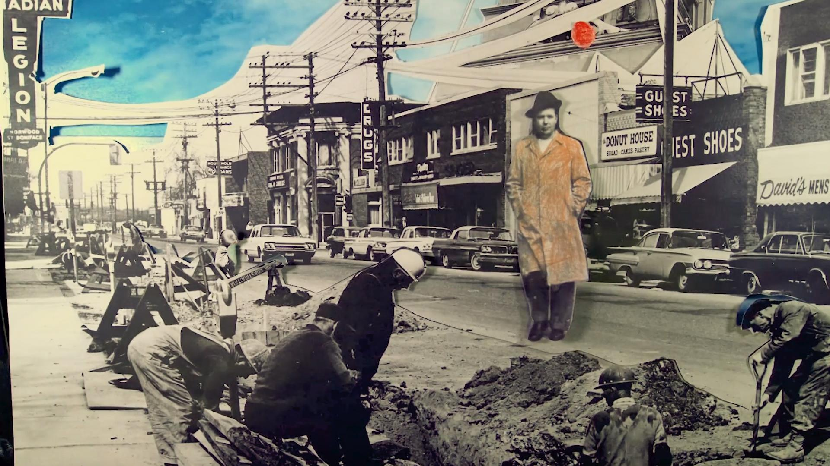
2D animation by Danielle Sturk
Young Rachel at El Toro Diner

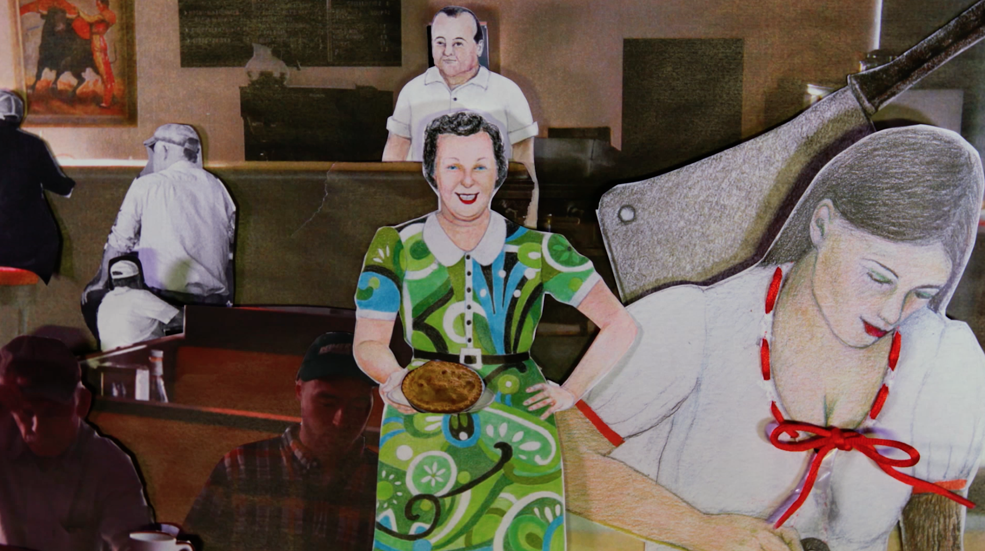
2D animation by Danielle Sturk

Contact

For distribution enquiries, a copy of the film or to organize a screening please contact:

Katy Slimmon, Distribution and Marketing for El Toro
+1 (204) 794-0400
filmeltoro@gmail.com

